**CREATIVE EDUCATIONAL SERVICES**

**BEGINNING OF TERM I EXAMINATIONS 2024**

**LITERACY 1A**

**PRIMARY THREE**

**Name:……………………………………Class: ……….……**

**School: ………………………………………..……………….**

1. What is the best food for babies?

––––––––––––––––––––––––––––––––––––––––––––––––––––––––

1. **Circle the living things.**

cow, water , tree , chair , sun , insect , bench , elephant

1. Why do we eat food?

––––––––––––––––––––––––––––––––––––––––––––––––––––––––

1. What is the use of ears on your body?

––––––––––––––––––––––––––––––––––––––––––––––––––––––––

1. **Name these things we use to clean our bodies.**

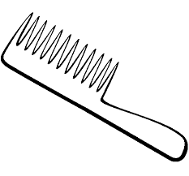 –––––––––––– 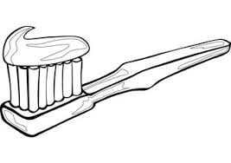–––––––––––––––

 ––––––––––– 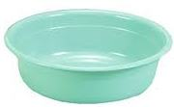 ––––––––––––––

1. List any two common diseases.
2. ––––––––––––––––––––––––––––––––––––––––––––––––––––––
3. ––––––––––––––––––––––––––––––––––––––––––––––––––––––
4. **Write Yes or No.**
5. A cow gives us milk. –––––––––––––––––––––––––––
6. A snake is a non-living thing.––––––––––––––––––––––––––-
7. I use my nose for seeing. –––––––––––––––––––––––––––
8. A father heads a home. –––––––––––––––––––––––––––
9. **Fill in the missing letters.**
10. g ____rd____n
11. pl____nt
12. st_____ne
13. f____ ____d
14. **Underline the immunisble diseases from the list below.**

malaria , polio , measles , flu , whooping cough.

10. How can you keep the compound clean?

––––––––––––––––––––––––––––––––––––––––––––––––––––––––

11. Mention any two non-living things.

1. ––––––––––––––––––––––––––––––––––––––––––––––––––––––
2. ––––––––––––––––––––––––––––––––––––––––––––––––––––––

12. Why do animals move from one place to another?

–––––––––––––––––––––––––––––––––––––––––––––––––––––––

13. What do we call animals kept at home?

––––––––––––––––––––––––––––––––––––––––––––––––––––––––

14. Draw and name any 3 animals kept at home.

|  |  |  |
| --- | --- | --- |
|  |  |  |
|  |  |  |

15. Why do we brush our teeth?

––––––––––––––––––––––––––––––––––––––––––––––––––––––––

16. What do we do after using the toilet?

––––––––––––––––––––––––––––––––––––––––––––––––––––––––

17. **Draw these basic needs of man.**

|  |  |  |  |
| --- | --- | --- | --- |
| Food | shelter | water | clothes |
|  |  |  |  |

18. Name the people who start up a family.

––––––––––––––––––––––––– and –––––––––––––––––––––––––

**SECTION B**

19. **Match these animals to their homes.**

sheep house

bird kennel

pig hutch

hen nest

dog sty

person pen

20a). What are living things?

–––––––––––––––––––––––––––––––––––––––––––––––––––––––

b). Give the two groups of living things.

1. ––––––––––––––––––––––––––––––––––––––––––––––––––––
2. ––––––––––––––––––––––––––––––––––––––––––––––––––––

c). **Write any three characteristics of living things.**

i). living things –––––––––––––––––––––––––––––––––––––––––

ii). living things –––––––––––––––––––––––––––––––––––––––––

iii). living things –––––––––––––––––––––––––––––––––––––––––

21a). Which element of weather gives us light and heat?

––––––––––––––––––––––––––––––––––––––––––––––––––––––

b). List any three things found in the school environment.

1. ––––––––––––––––––––––––––––––––––––––––––––––––––––
2. ––––––––––––––––––––––––––––––––––––––––––––––––––––
3. ––––––––––––––––––––––––––––––––––––––––––––––––––––

c). Name these things we use to keep our school environment clean.

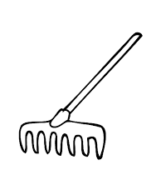––––––––––––––– 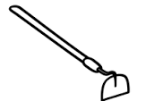–––––––––––––––––

––––––––––––––

22a) ––––––––––––––– animals are animals which leave in the bush / forest.

b). **Write the animals movements.**

(walking , slithering , flying , jumping)

1. A bird moves by –––––––––––––––––––––––––––––––––––––
2. A snake moves by –––––––––––––––––––––––––––––––––––
3. A person moves by ––––––––––––––––––––––––––––––––––
4. A person moves by ––––––––––––––––––––––––––––––––––

23. **Name the parts of the head.**

a



e

d

c

b

1. ––––––––––––––––––
2. ––––––––––––––––––
3. ––––––––––––––––––
4. ––––––––––––––––––
5. ––––––––––––––––––

24. **How many –––––––– do you have?**

a. I have ––––––––––––– eyes.

b. I have ––––––––––––– mouth.

c. I have ––––––––––––– ears.

**END**